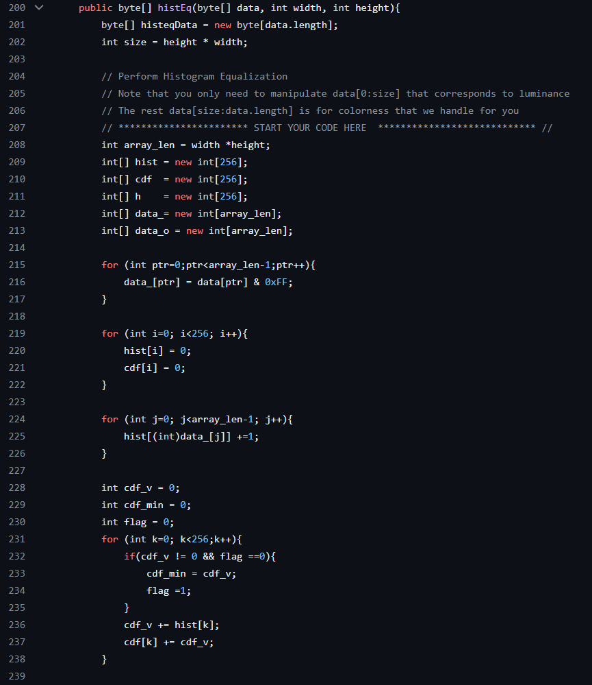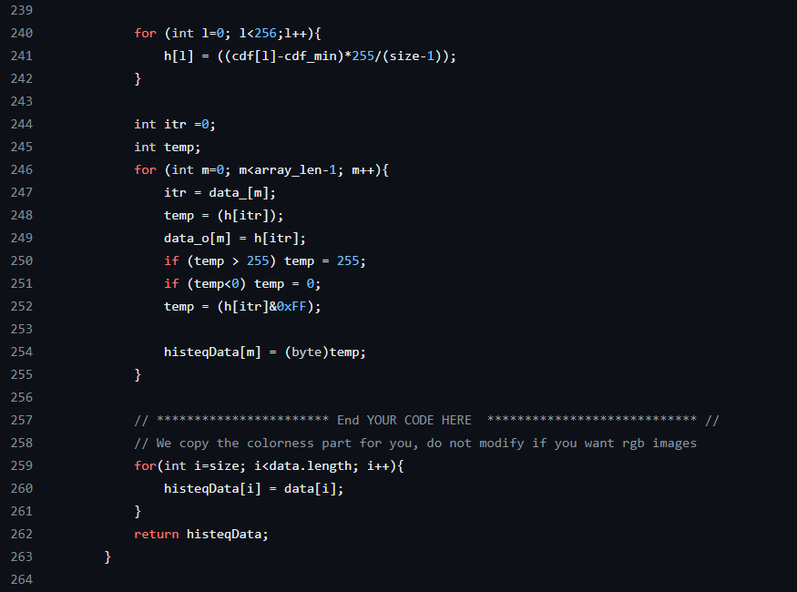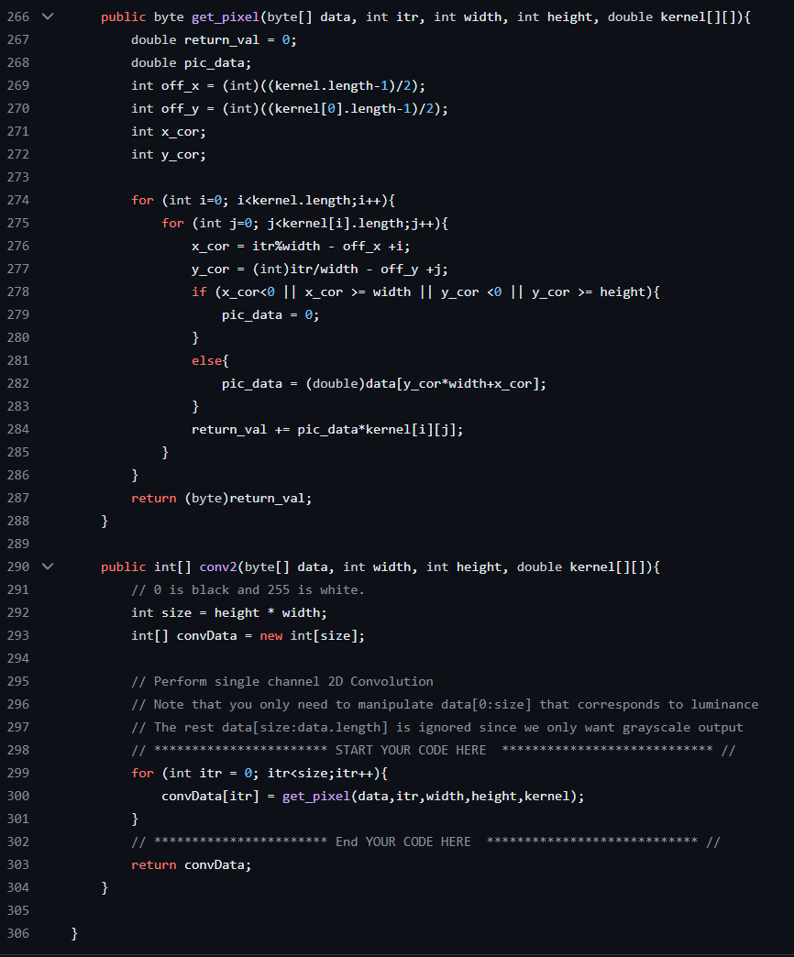

Question:

When the original image has low dynamic range (the brightness gradient is low), the his_eq would be most significant.

For a 3x3 kernel on a 512x672 frame, we need 9 computation for each pixel making it 9*512*672 = 3096576